COMPUTER HARDWARE PRACTICAL LAB

PC Assembly & Disassembly Lab Report

Task 1: Main Components Inventory

Upon opening the desktop PC cabinet, the following internal core hardware components were identified and inspected:
Motherboard: The main printed circuit board (PCB) that hosts and interconnects the CPU, RAM, storage drives, and expansion cards, facilitating communication via system buses.
Central Processing Unit (CPU): The primary microchip acting as the "brain" of the PC; it executes instructional sequences, performs arithmetic/logic operations, and controls data flow.
CPU Heat Sink & Fan: A dedicated cooling assembly attached directly onto the CPU to dissipate thermal output efficiently, preventing critical overheating and thermal throttling.
Random Access Memory (RAM): Volatile, high-speed temporary storage slots that provide the CPU with quick-access data pathways for running processes and active programs.
Power Supply Unit (PSU): A hardware component that converts high-voltage Alternating Current (AC) electrical power from a wall outlet into lower, regulated Direct Current (DC) required by internal modules.
Hard Disk Drive (HDD) / Solid State Drive (SSD): Non-volatile storage mediums utilized for permanent data retention, housing the operating system file architecture, applications, and user libraries.
Graphics Processing Unit (GPU / Video Card): A dedicated expansion card or integrated processor designed specifically to accelerate image, video rendering, and 3D display outputs.

Task 2: Step-by-Step Disassembly Guide

The step-by-step physical breakdown of the desktop workstation was performed according to
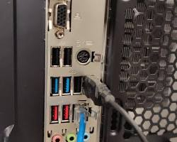
STEP 1: DISCONNECT EXTERNAL CONNECTIONS
Action: Shut down the operating system completely, turn off the PSU switch, and completely unplug the main AC power cord, display monitor lines (HDMI/DP), input peripherals, and networking cables.
Caption: Isolating the PC tower from all live external sources eliminates shock risks and grants physical freedom
to manipulate the chassis safely on an anti-static work area.
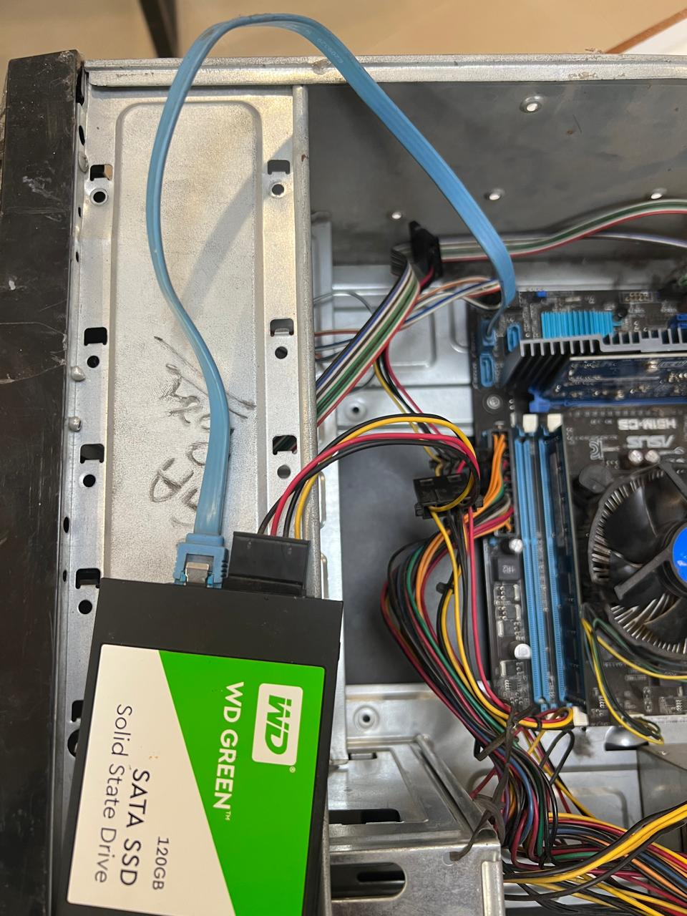
STEP 3: UNPLUG INTERNAL POWER AND DATA CABLES
Action: Unclip and pull the 24-pin ATX main motherboard connector, the 4/8-pin CPU auxiliary connector, SATA power/data cords from storage bays, and front-panel interface lines (Power/Reset switches).

Caption: Systematically freeing components from the complex web of power and data lines ensures no hardware
gets structural strain or catches during extraction.
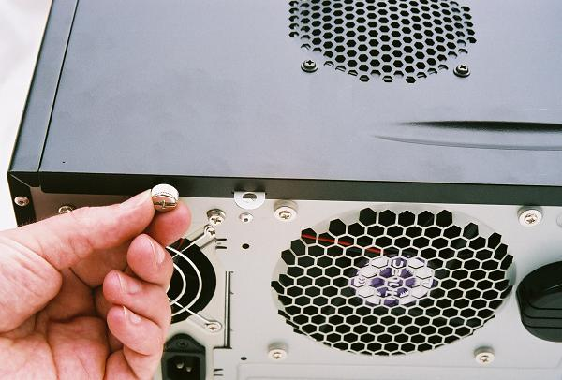
STEP 2: REMOVE THE SIDE PANEL
Action: Unscrew the case thumb-screws or structural retention screws securing the left side chassis cover panel. Slide or swing the panel back and set it aside carefully.
l]
Caption: Detaching the main access panel exposes the inner system framework and provides unobstructed
manual and visual clearance to the components.

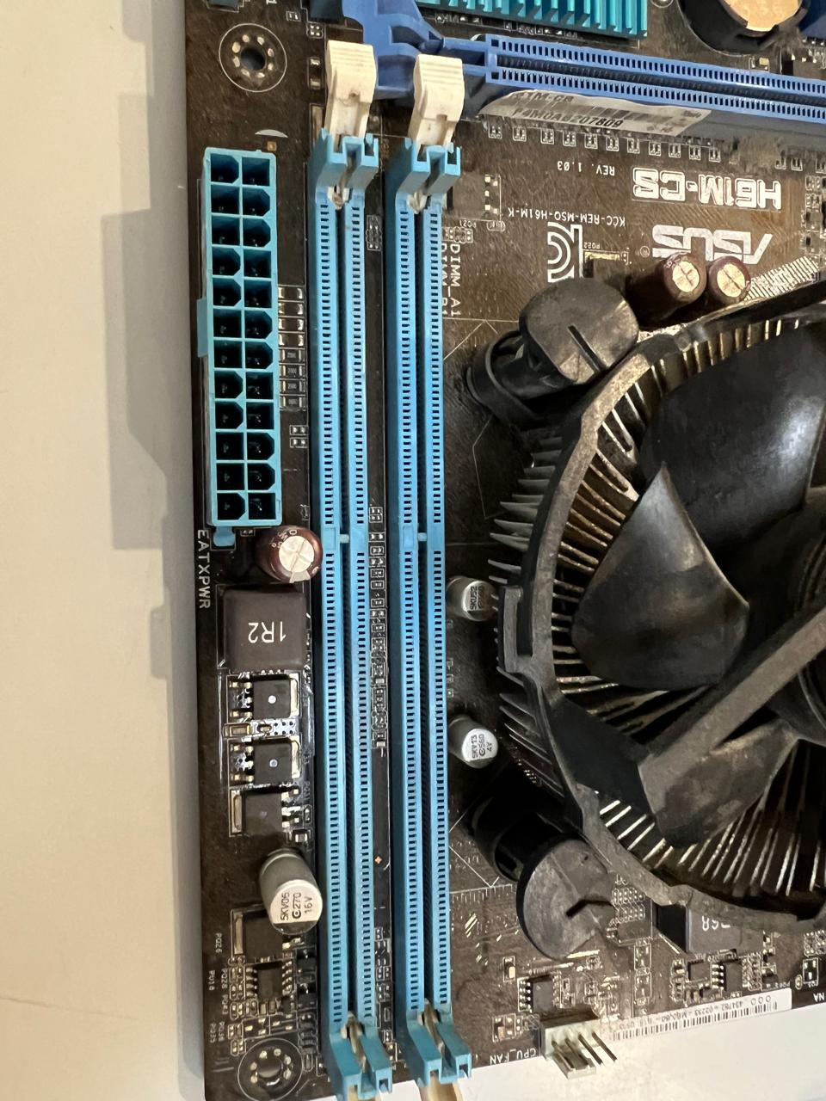
STEP 4: REMOVE THE RAM MODULES
Action: Press the dual or single plastic retention tabs located at the ends of the DIMM slots outward until the RAM stick naturally ejects upward, then grip the module solely by its plastic edges.
[
Caption: Removing RAM early keeps these small, highly fragile modules safe from accidental knocks or
scratches while extracting bulkier surrounding parts.
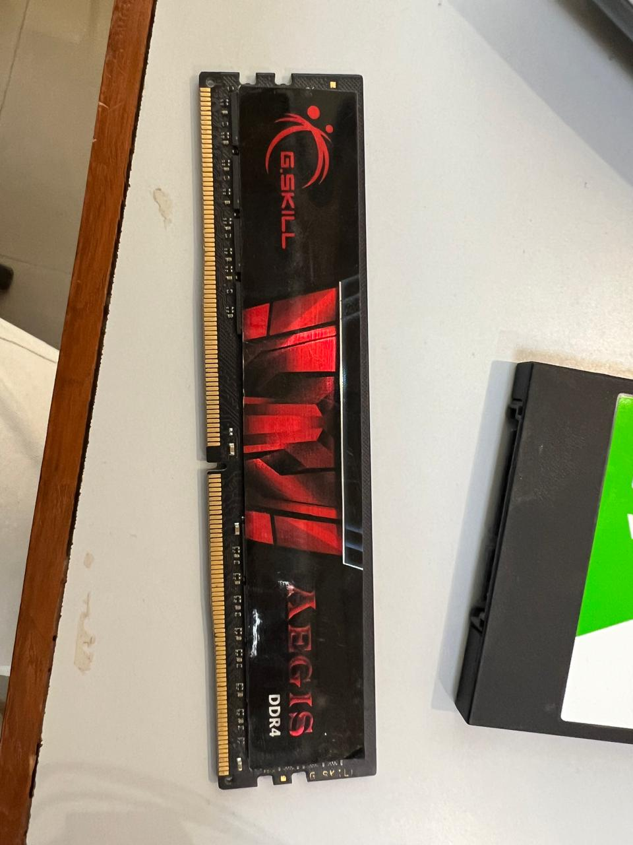
STEP 5: EXTRACT STORAGE DRIVES (HDD/SSD)
Action: Locate the drive bays or bracket mounts, unscrew the securing hardware from the chassis rail system, and smoothly glide the storage unit out of its compartment.
[
Caption: Detaching fragile physical storage components keeps internal platter disks (HDDs) safe from vibration
impacts and shock damage.
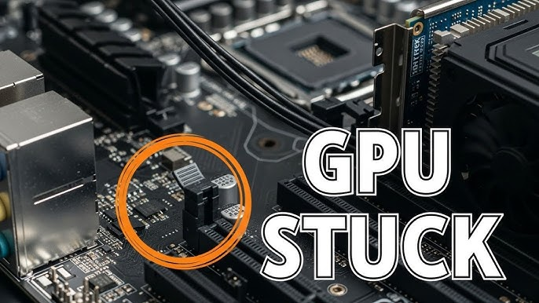
STEP 6: REMOVE DEDICATED EXPANSION CARDS (GPU)
Action: Unscrew the external expansion bracket fastener securing the graphics card to the rear PCI window slot, press down the plastic PCI-e latch mechanism, and pull the card straight up.
[
Caption: Removing the long, heavy GPU early prevents structural bending or warping stress on the delicate
motherboard expansion traces.

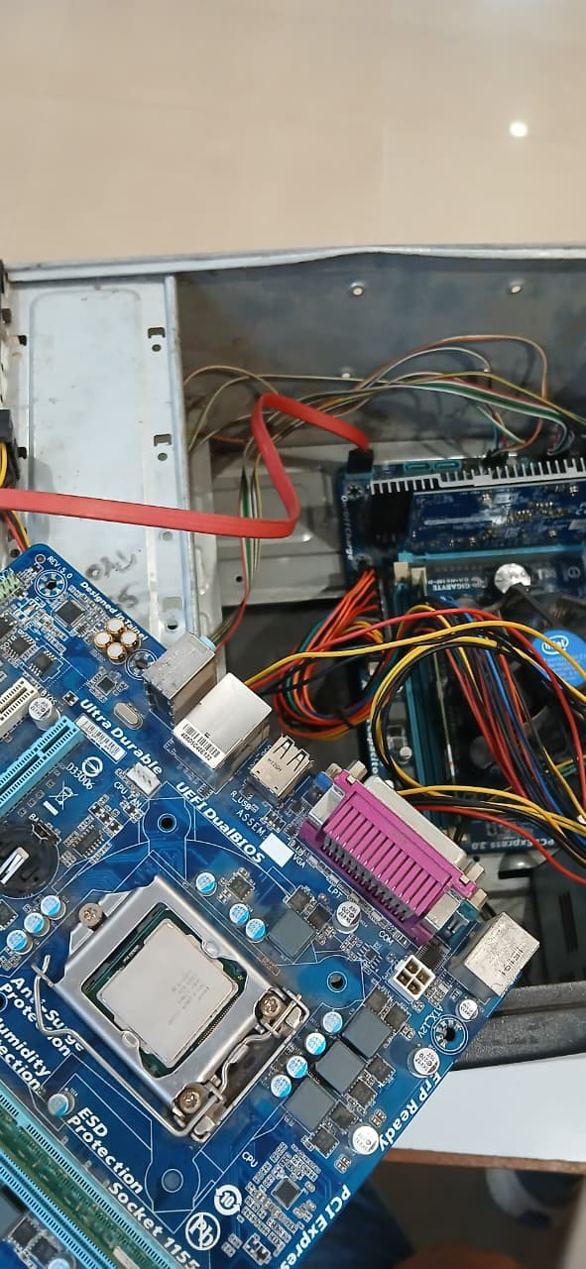
STEP 7: UNMOUNT AND EXTRACT THE MOTHERBOARD
Action: Unscrew all layout mounting screws anchored into the underlying chassis standoffs. Carefully lift the motherboard upward diagonally, ensuring no peripheral pins rub against the back I/O cutout.
[
Caption: The core motherboard is removed last with the CPU and cooling fan left attached, minimizing
component handling and flexing of the main board.

Task 3: Step-by-Step Reassembly Guide

Reassembling a computer is not merely a direct reversal of disassembly; it follows a precise modular hierarchy. Components must be re-installed in a systematic sequence to optimize physical spacing and cable organization.
1. Core
Bench Prep
→
2. Board &
PSU
Seating
3. Drive
Mounting
4. Power/Data
Routing
→
→
→
5. GPU & 6.
RAM POST
Seating → Test &
Close

Pre-Chassis Installation (The Outer Build)
Procedure: Place the clean motherboard on a non-conductive surface. Insert the CPU into the socket alignment markers, close the bracket lever, apply a pea-sized dot of thermal compound, secure the heat sink fan power wire to the 'CPU_FAN' header, and populate the designated primary RAM slots.
Why the Order Matters: Attempting to seat a bulky CPU cooler, locking a zero-insertion-force lever, or applying leverage to lock down RAM modules after the motherboard is inside a cramped, dark steel case is extremely difficult and increases the risk of slipping and scratching the PCB circuit traces.

Installing Board & PSU to Chassis
Procedure: Align and press the back panel I/O Shield cleanly into the rear cutout of the PC chassis. Lower the motherboard on top of the matching brass chassis standoffs, screw them down securely without over-tightening, and mount the Power Supply Unit into its bottom/top designated bay.
Why the Order Matters: The motherboard must be perfectly stationary and grounded on its standoffs before any heavy-gauge electrical cables are pulled across it or plugged into its power headers.

Mounting the Storage Drives
Procedure: Slide the SSD/HDD units into their designated brackets and fasten them down using mechanical drive screws or toolless locking frames.
Why the Order Matters: Drives must be fully secure in their final physical resting layout before any delicate data connection cables are hooked up, eliminating stress on the SATA ports.

Routing Cable Framework
Procedure: Pull the thick 24-pin main power line, 8-pin CPU line, and SATA data leads through cable routing holes. Connect the small front-panel pins (Power SW, Reset SW, Power LED, HDD LED) carefully to their respective motherboard pins based on the technical pin diagram.
Why the Order Matters: Plugging in these primary cables early gives maximum manual dexterity to route thick wiring bundles neatly, keeping them clear of cooling fans before the space becomes restricted.

Seating the Graphics Card (GPU)
Procedure: Align the GPU interface with the primary PCIe x16 slot, press down firmly until the latch snaps closed, screw the card bracket to the case rear frame, and plug in the auxiliary 6/8-pin PCIe power links.
Why the Order Matters: The GPU is the single largest component and cuts right through the center of the workspace. Installing it last ensures it does not block access to your motherboard headers, SATA ports, or wiring channels.

Final Functional Boot Test & Buttoning Up
Procedure: Connect the AC power cord and a display monitor to perform a brief Power-On Self-Test (POST). Confirm fans spin up and the BIOS interface displays on screen. Shut down, organize any loose wires with zip ties, and lock the side panels back onto the computer case.

Task 4: Safety Precautions and Tools Checklist
Tool / Precaution Importance & System Lifecycle Purpose

Phillips Head Screwdriver (#2)
The fundamental standardized mechanical interface tool for computer construction. Using the correct size avoids stripping standard case, standoff, drive, and expansion slot screws.

Anti-Static Wrist Strap / Grounded Mat
Maintains equalized electrical potential between your body and the metal PC case chassis. This completely prevents Electrostatic Discharge (ESD)—which can instantly rupture microscopic logic gates on chips without your knowledge.

High-Quality Thermal Paste
Fills the microscopic mechanical air gaps existing between the integrated heat spreader of the CPU and the flat base of the cooling block, ensuring optimal thermal transfer.

Zip Ties or Velcro Strips
Groups internal data and power cables out of the path of spinning cooling fins, ensuring unrestricted dynamic airflow and long-term dust management.

Complete AC Cord Disconnection
A mandatory physical safety measure. Eliminates standard shock hazards to the user and prevents shorting out live low-voltage standby rails (+5Vsb) on the motherboard during physical handling.

Handling Parts by Outer Edges Only
Importance & System Lifecycle Purpose
Tool / Precaution
Protects exposed sensitive surface-mount capacitors and copper traces. Prevents natural finger oils and sweat from creating minor localized corrosion points or electrical resistance problems over time.

